


Headlands School

Accessibility Strategy and Plan

This local policy conforms to the Independent School Standards Wales Regulations 2003:

Section 5(v)

Equality Act 2010/Statutory Duties (Wales) Regulation 2011

  - Involvement of pupils, staff and parents
Headlands is committed to providing equality of opportunity and access for all children, and to promoting high achievement for all. The key principles underpinning this commitment are expressed as follows:

- The best interest of each and every child
A carefully balanced approach is required with an emphasis on the needs of each child and the planned development of more individualised approaches to education. This will be addressed in the admissions planning process.

- Early intervention
Early identification and early intervention are essential to overcome barriers to access to learning.

- The views of the child
Children must be heard and take part in decisions about their education.

- Working with parents
Everyone involved with the child must work together, including parents, schools, other statutory and voluntary agencies.

  - Action for Children and Headlands School policies, practices and plans focus on promoting access for all children to a broad, challenging and exciting curriculum, which will enable them to play a full part in their school and wider community.

  - Headlands School Plans for Inclusion and Support for Learning will set out clear objectives and strategies to promote access and inclusive practice.

- DEFINITION OF DISABILITY

  - The Equality Act 2010 uses a broad definition of “disability”. A person has a disability if he or she has a physical or mental impairment, which has a substantial and long term adverse effect on his or her ability to carry out normal day to day activities.

  - Physical impairments can include sensory impairments (such as those effecting sight and hearing) and mental impairments include learning difficulties and mental illness (if it is recognised by a respected body of medical opinion).

  - An impairment is seen to affect normal day to day activities if it affects one or more of the following:

Mobility, manual dexterity, physical co-ordination, continence, ability to lift, carry or otherwise move everyday objects, speech, hearing, eyesight, memory, ability to concentrate, learn or understand, and perception of physical danger.

- RESPONSIBILITIES

  - Action for Children has a legal duty to prepare accessibility strategies for its schools.

  - The Accessibility Plan may be inspected by Estyn.

  - Main priorities:

Priority | Success Criteria | Means of Evaluation/Action | Timescale
Provision of equality and diversity training for all staff | 100% staff have undertaken training | Regular review training database to identify any gaps | One year
Provision of equality and diversity awareness for pupils | All pupils will have an understanding of the nature of disability equality through PSE lessons | Evidenced through curriculum files | Within one year of pupils being admitted and on-going reinforcement
Eliminate unlawful discrimination | All staff to be aware of the Whistle Blowing Policy.  Consideration of disabilities when analysing data. | Zero incidents to report.  Analysis of data through Pupil Support Team meetings and self-evaluation reviews to identify any disability issues. | Within first six months induction period for each staff member.  On-going.
Eliminate harassment of disabled people relating to their disability | Headlands School has a robust anti-bullying policy. | Reduction of incidents, any reports are dealt with according to policy and that pupils feel safe to communicate issues to staff. | On-going
Promote positive attitudes to disabled people | Positive role models introduced to pupils and staff.  Ballot elected student council. | Two Paralympic athletes invited to share their experiences with staff and pupils.  Non-discriminatory elections. (see appendix A1) | On-going
Encourage participation by disabled people in public life | Pupils can access community with confidence and take part in work experience placements in local businesses. | Positive feedback from work experience placements. Annual review reports.  Evidenced by pupils participating in sports events (Special Schools – see appendix A2). | On-going
Take steps to meet disabled people's needs, even if this requires more favourable treatment | - Visual aids to help with sight impairment are available and relevant staff trained in their use.  - Ramps and railings installed to aid access to buildings.  - Counselling – wellbeing hub available to staff via intranet.  Independent advocacy available to pupils.  - Disability not considered at interview stage for anyone who meets job requirements.  - Disabled toilet has been installed in the café complex.  - Specialised bikes available for pupils with dyspraxia or co-ordination problems. | - Feedback from external visual impairment support worker provided when appropriate. Previous visits provided positive feedback.  - Installed where identified and pupils with physical disabilities can access buildings with minimum assistance.  - Reduction in stress related absences.  - Evidence of personnel appointed with disabilities. | On-going

- INCREASED ACCESS TO THE PHYSICAL ENVIRONMENT

  - Building improvements are undertaken through two main routes:

- All planned major capital schemes include measures such as ramps, lifts or toilets where possible for the disabled to ensure that pupils can access the buildings.

- Pupils’ admission to school may be done in liaison with the Education Service for Physical Disability, the Hearing Impaired Service or the Visually Impaired Service as appropriate.

  - Headlands School may use funds to support access in one or more of the following ways.

- Improved physical access to the school. This may include setting down and picking up points, ramps, handrails and lifts.

- Improve physical movement around the building, including adaptations for sensory disability such as improved colour schemes and access, to social areas, dining rooms etc.

- Improved accommodation within the building; including toilets for disabled pupils and sound proofing for hearing impaired pupils.

- Provision of specialist furniture such as rise and fall tables, sinks, ovens, information and communication technology (both hardware and software).

- INCREASED ACCESS TO WRITTEN MATERIALS

  - Action for Children and Headlands School has a duty to plan to make written information normally provided to pupils available to disabled pupils. The information should take account of pupils disabilities, pupils and parents preferred formats and be made available within a reasonable time frame.

  - This duty may relate to pupils with hearing and visual impairments. However it can also relate to other disabilities at Headlands School, specifically pupils with social, emotional behavioural difficulties and high functioning ASD, speech and language disorders and specific learning difficulties.

  - Headlands School provision for children with these disabilities will be helped by good links with a range of local services via LEA, health trusts or social services.

  - Action for Children provides Headlands School with information about its support services and the facilities they are able to offer.

  - Action for Children and Headlands School ensures that it makes appropriate arrangements for written information normally provided to their pupils available in other formats on request.

- PARTICIPATION IN THE SCHOOL CURRICULUM

  - Our objectives include helping support teachers and teaching assistants in developing and using inclusive approaches which enable all pupils to access opportunities to achieve the highest possible standards. Specific initiatives may include:

- Supporting and promoting the educational inclusion of pupils with disabilities and special educational needs through the audit of current practice, the promotion of a school self-review process, the dissemination of good practice through Action for Children guidance documentation, and in-school consultancy.

- Developing good practice in schools in writing, implementing and monitoring effective and manageable Individual Education Plans (IEPs) and Individual Crisis Management Plans (ICMPs).

- Promoting effective practice in school to work in active partnership with parents in meeting the needs of children with disabilities and other special educational needs.

- Encouraging pupil participation and decision making in line with the SEN code of practice.

- Advocating participation in the school curriculum and in activities such as leisure and sporting events and school trips.

  - Action for Children and Headlands will provide a range of professional development programmes for its staff, designed to equip them to meet the needs of children with a range of disabilities and learning difficulties.

Action for Children supervision and appraisal systems will assist Headlands School to audit our own training needs in the fields of inclusion and access, and to engage at appropriate levels with LEAs and other professional development opportunities.

Headlands School will continue to promote the accelerated progress of pupils with learning difficulties through support in 6 skill areas and emotional and social skills via targeted training for teachers and teaching assistants, and the dissemination of national and locally produced guidance materials on appropriate curriculum and effective pedagogy.

- RESOURCES

  - Improving the physical environment of Headlands School is an important aspect of the work undertaken by Action for Children’s property services. New works will take this into account.

- MONITORING AND EVALUATION

8.1 A formal review of Headlands School Accessibility and Disability Equality Plan will be undertaken on an annual basis as part of the business planning model for Action for Children. Adjustments to be made where identified.

Report Author: Maria Farmer
Date of Review: May 2023

Accessibility Plan – Disability Equality Duty Headlands School
Appendix A

Visit of Para Olympic medallist to school at the opening event of our ‘Sip & Serve’ café

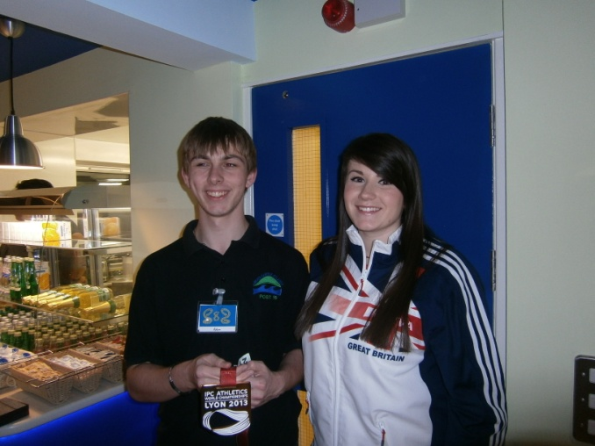

- Pupils taking part in a special school’s rugby event at Trinity Fields
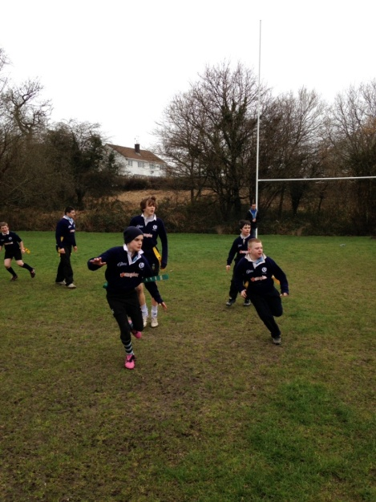

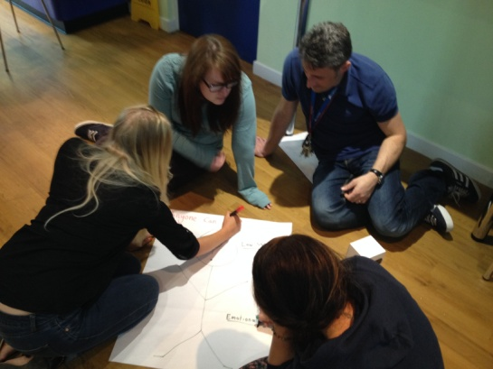
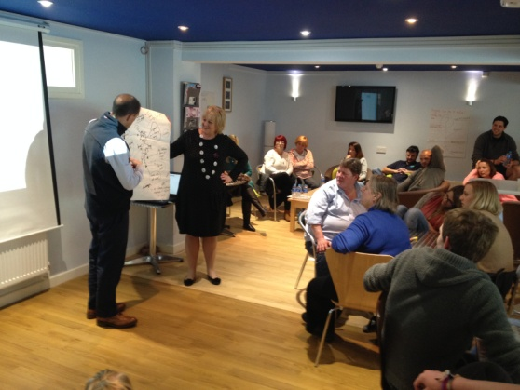
- Staff receiving anti-bullying training

