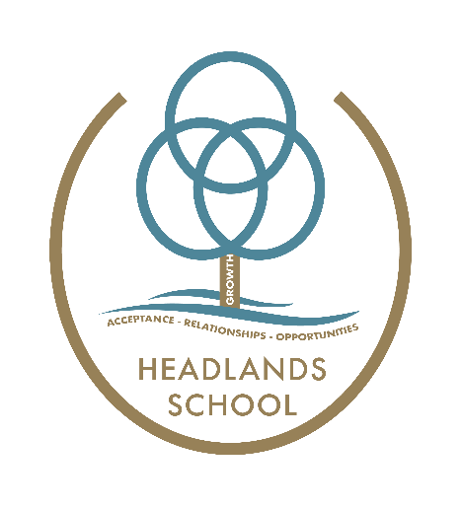
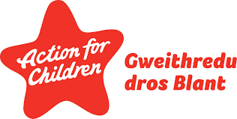

Headlands School
PSE Policy
Vision statement:
For all pupils to develop an understanding of the ever-changing world in which we live; develop the skills necessary to take responsibility for their future life choices and to enable them to live safe and happy lives.
This local policy conforms to the Independent School Standards Wales Regulations 2003: Section – 1(2)(e)
Introduction
PSE, health and wellbeing are embedded in the ethos and culture of Headlands School. It plays a fundamental part of school life and is at the heart of the curriculum. PSE at the school enables children and young people to develop a sense of self-worth and teaches them how to interact appropriately with others and establishes opportunities for increased pupil involvement in school life.
Our philosophy at Headlands School
At Headlands we believe that every child can be understood in the context of their life experiences. We are mindful of the disruption, trauma and adversity many of our young people have experienced prior to their arrival here. Consequently, we aim to create safety and security for each child as a primary goal.
We have made a conscious choice to hold a position of acceptance of where the child is at the point they come to Headlands, and a belief that all behaviour makes sense in the context of their experience AND to support them to develop healthy behaviours and relationships during their time at Headlands.
Relationships are at the heart of everything we do, both for staff, children and young people, and the other professionals we engage with in our work for young people. We believe in relationships as the most powerful agent of change and the value we place on genuine connected relationships can be seen at every level, from day to day interactions in the home and classroom, to our policy documents and formal review processes.
Aims
At Headlands School we aim to promote the personal and social development of our pupils by delivering a curriculum that:
- Develops learners’ self-esteem and a sense of personal responsibility,
- Promotes self-respect, respect for others and celebrates diversity,
- Equips learners to live safe, healthy lives,
- Help our pupils understand and manage their feelings,
- Prepares learners for the choices and opportunities of lifelong learning,
- Help pupils identify ways of responding to peer pressure,
- Empowers learners to participate in their schools and communities as active responsible citizens locally, nationally and globally,
- Fosters positive attitudes and behaviour towards the principles of sustainable development and global citizenship,
- Prepares learners for the challenges, choices and responsibilities of work and adult life,
- Acknowledges that our pupil population are vulnerable young people that require additional support in making good decisions due to the difficult situations they often find themselves in.
The PSE team supports whole school approaches through:
- Discrete timetabled curriculum time,
- Teaching PSE through other curriculum areas,
- PSE activities and other school events e.g. national initiatives such as Safer Internet Day, Alcohol awareness week and Anti-bullying week.
- When identified, specific sessions following feedback from the PST (pupil support team) identifying trends in difficult/inappropriate behaviours (e.g. bullying, name-calling, racism, personal space issues, homophobia etc.). The PSE team consequently plan specific actions to deal with this behaviour in a proactive way through interventions such as circle time, 1:1, group or whole group sessions.
- Drama sessions incorporate the termly PSE themes which offers a thematic approach to learning and reinforces key learning points,
- Successful working partnerships with outside agencies including South Wales Police, Switched On, NHS Vale Health Service, Llamau, Fflag, Fearless
- Using DDP principles in order for all pupils to develop a positive sense of self and build trusting relationships with both staff and peers.
Due to the diverse nature of PSE this policy should be read in conjunction with the schools’ policies on inappropriate use of drugs and alcohol policy, Relationship & Sexuality Education policy, safeguarding policy, and the bullying policy, all of which are in the PSE curriculum folder.
The PSE policy should also be read in conjunction with the Headlands School ‘Wellbeing Curriculum’ (Please see PSE curriculum folder).
Planning
At Headlands School a PSE Scheme of Work has been designed especially for the needs of the young people. The Scheme of Work includes yearly planners and a Curriculum Map showing topics and learning objectives.
Half-termly planning and lesson plans give details of learning outcomes, appropriate activities and shows skills developed. Links to the other Areas of Learning that are to be developed are shown on the half-termly planning and are utilised when it is the most efficient and effective way of meeting the lesson objectives.
Teaching
At Headlands School PSE uses a holistic approach to embed PSE in all areas of the young person’s education and a variety of teaching approaches are used (see Appendix 1). PSE is delivered through 2 timetabled lessons per week, tutorial sessions, circle time and 1:1 sessions. Pupils’ social and emotional wellbeing is continually developed through staff use of DDP and TCI.
Pupils in key stage 3 begin their BTEC qualifications, pupils in key stage 4 and Post 16 gain qualifications in PSE through SWEET BTEC level 1 & 2 which has 8 topic areas – Improving Physical Health and Wellbeing; Understanding Emotional Wellbeing; Understanding the Role of Relationships in Social Health and Wellbeing; Understanding Sexual Health and Wellbeing; Developing Personal Identity; Improving Personal Impact on the Environment; Financial Commitments; Producing a Personal Progression Plan.
A new curriculum in Wales
The Health and Well-being Area of Learning and Experience provides a holistic structure for understanding health and well-being. It is concerned with developing the capacity of learners to navigate life's opportunities and challenges. The fundamental components of this Area are physical health and development, mental health, and emotional and social well-being. It will support learners to understand and appreciate how the different components of health and well-being are interconnected, and it recognises that good health and well-being are important to enable successful learning.

Engagement with this Area will help to foster a whole-school approach that enables health and well-being to permeate all aspects of school life.
What matters in this Area has been expressed in five statements which support and complement one another and should not be viewed in isolation. In order to achieve this holistic approach, teachers should seek to draw across all five statements when planning activities.

Together they contribute to realising the four purposes of the curriculum | Effective realisation of the vision described in this Area is fundamental to developing healthy, confident individuals, ready to lead fulfilling lives as valued members of society.
 | By developing learners’ motivation, resilience, empathy and decision-making abilities, they can be supported to become ambitious, capable learners, ready to learn throughout their lives.
 | Learners can also be supported to become ethical, informed citizens of Wales and the world by developing their ability to show respect, to value equity, to listen to others and to evaluate the social influences affecting them.
 | Through enabling learners to manage risks, express ideas and emotions, develop and maintain healthy relationships, and take on different roles and responsibilities, the learning and experience in this Area can support learners to become enterprising, creative contributors ready to play a full part in life and work.
What matters in Health & Wellbeing has been expressed in five statements:

Developing physical health and well-being has lifelong benefits.

How we process and respond to our experiences affects our mental health and emotional well-being.

Our decision-making impacts on the quality of our lives and the lives of others.

How we engage with social influences shapes who we are and affects our health and well-being.

Healthy relationships are fundamental to our well-being.
The Health & Wellbeing Area of Learning and Experience draws on subjects and themes from PE, mental, physical and emotional well-being, Relationship & Sexuality Education, parenting, healthy eating and cooking, substance misuse, work-related learning and experience, and learning for life. It is also concerned with how the school environment supports children and young people’s social, emotional, spiritual and physical health and well-being through, for example, its climate and relationships, the food it provides, its joint working with other relevant services such as health and social work, and the access it provides to physical activity.
Given that our pupil population are vulnerable young people, that require additional support in making good decisions, we use Relationship and Sexuality Education, internet safety lessons and radicalisation lessons to teach our young people how to keep themselves safe, and who to tell when they find themselves in difficult situations.
RSE
RSE is a positive and protective part of the Curriculum for Wales and Headlands School. It plays a central role in supporting learners’ rights to enjoy fulfilling, healthy and safe relationships throughout their lives.
RSE should support learners to develop the knowledge, skills and values to understand how relationships and sexuality shape their own lives and the lives of others. Learners should be equipped and empowered to seek support on issues relating to RSE and to advocate for self and others
The RSE we provide at Headlands school is always developmentally appropriate for our learners. We take account of a range of factors such as the leaner’s age, knowledge and maturity and any additional learning needs when planning RSE to ensure that the RSE we deliver is developmentally appropriate for each learner.
Assessment & Principles of Progression & Descriptions of learning
We currently use ‘Connecting Steps’ to gain an understanding of YP’s NC levels and track progression. Written and verbal feedback helps children to recognise the progress they are making in developing skills and taking part, as well as in their knowledge and understanding. This assessment should not be judgemental and feedback given should be DDP congruent and suggests the way forward or a curious observation about work/answers given.
Progression within the Health and Well-being Area must enable learners to revisit and deepen learning in concepts within the statements of what matters across a wide range of topics and aspects of health and well-being. Learners’ contexts, their personal concerns, interests and circumstances will all have an impact on what enables them to progress and the pace at which they progress. This is particularly relevant in the context of feelings and emotions.
Descriptions of learning provide guidance on how learners should progress within each statement of what matters as they journey through the continuum of learning. Descriptions of learning provide guidance on how learners should progress within each statement of what matters as they journey through the continuum of learning. These are arranged in five progression steps which provide reference points for the pace of that progression as listed above in a new curriculum in Wales.

Drama and PSE
Drama and PSE at Headlands School are inextricably linked – themes are planned jointly, and drama allows pupils to explore and express an array of feelings and emotions, situations and roleplay activities to reinforce topics taught in PSE. A theatre in education group has formed to create productions based on important and relevant topics such as anti-bullying, LGBT, loneliness and are performed to pupils, staff, parents and visitors.
Prevent – Radicalisation & Extremism
At Headlands School we aim to identify and protect children who may be vulnerable to radicalisation, whether these come from within their family or are the product of outside influences.
We build pupils’ resilience to radicalisation by debating controversial issues through providing a safe space in which children, young people and staff can understand the risks associated with terrorism. This also develops knowledge and skills to challenge extremist arguments. Headlands School provides a safe environment in which pupils can discuss issues such as extremism and terrorism in an age-appropriate and balanced way. Issues such as stereotyping, propaganda, online safety, and freedom of speech are all relevant to the debate, and for some age groups and areas topics such as terrorism, religious fundamentalism and global issues will also be appropriate. Understanding the perspectives of others and actively debating these issues plays an important role in building the resilience to radicalisation, whether inspired by far right, Islamist or any other extremist ideology.
If we are worried or concerned that a pupil might be at risk of radicalisation or that they are displaying extremist views, then we can discuss these concerns with Maxine Cahill our safeguarding officer or our school police liaison officer – PC Alex Reed who could then make a referral to PREVENT. Staff at Headlands receive training through our police liaison partnership on PREVENT and have received WRAP training.
LGBTQ+ inclusive
Headlands School is a place where every person has the right to be themselves and to be included in a safe and happy environment. Everyone at our school is equal and should be treated with respect. Difference and diversity are celebrated across the school by supporting and accepting pupils’ choices in their sexual orientation and gender identity. Where pupils are questioning their sexuality or gender or are openly LGBTQ+ we aim to promote understanding and support the needs of pupils through specific lessons and one-to-one sessions. Pupil Support Team also regularly monitor homophobic, biphobic or transphobic language and bullying and PSE staff are proactive in their response in tackling such bullying during tutorial sessions, PSE lessons or drama sessions.
Safe use of internet
Pupils at Headlands School sometimes have difficulties in using the internet safely (whether this is the use of social media, gaming platforms, or online messaging). Difficulties can arise following pupils having negative interactions and experiences online with each other or with members of the public. Due to the nature of our pupils they require specific sessions about what to do if they find themselves in a vulnerable situation online or a situation that makes them feel uncomfortable. PST monitor instances of unsafe use of internet and the PSE team educate pupils on appropriate safe use of the internet and who they can talk to if they are worried about anything. PC Alex Reed delivers regular sessions, teaching pupils the SMART rules when using the internet.

Written by: S Powell & R Evans
Date: May 2023
Review Date: May 2024

Appendix 1
Teaching Strategies
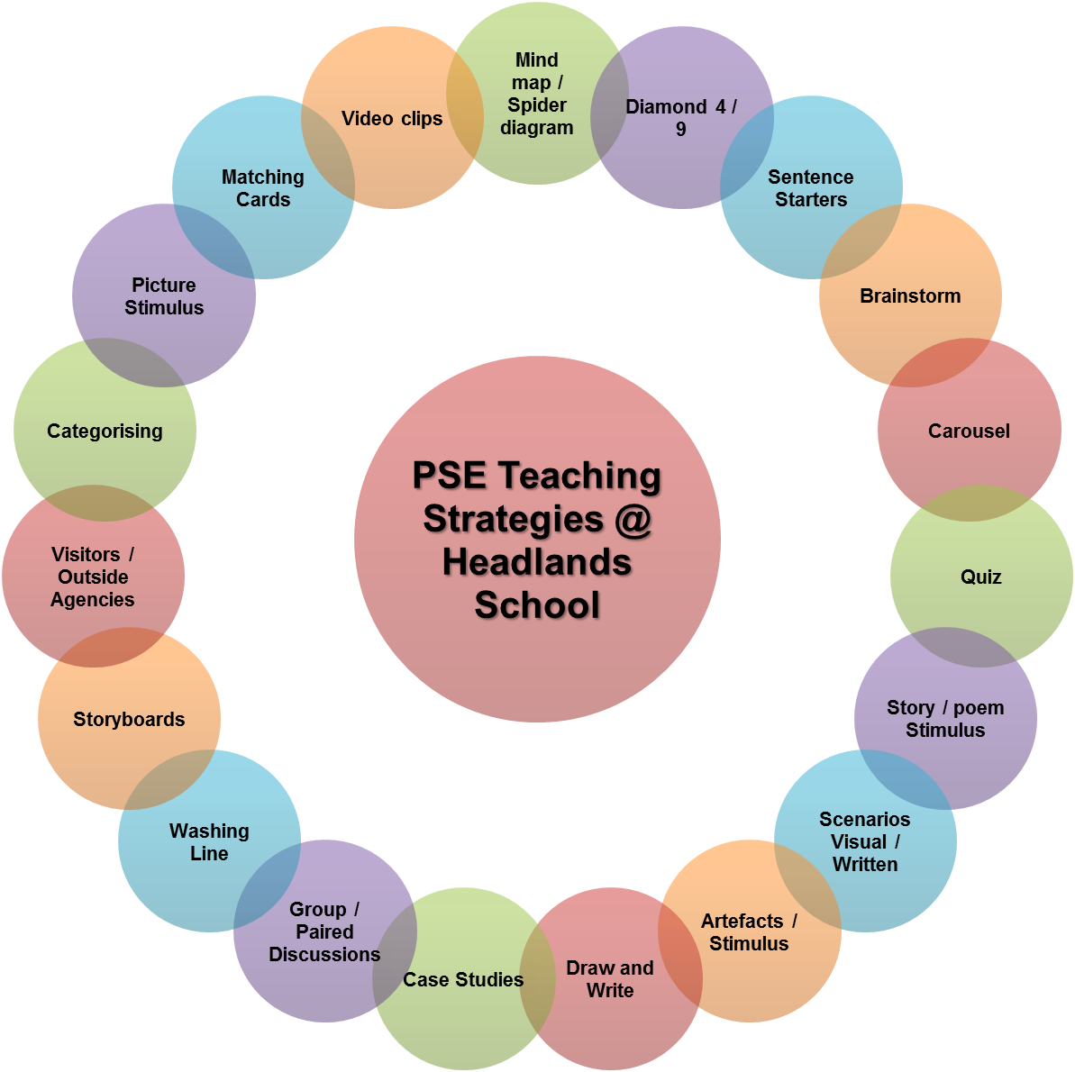

PSE Curriculum Map Lower School
Appendix 2 – Curriculum Map
 | Autumn 1 | Autumn 2 | Spring 1 | Spring 2 | Summer 1 | Summer 1
Year  One  2021 - 2022 | Mental Health & Emotional Wellbeing  - Friendships  - Feelings  - Keeping calm  - Mindfulness |   Relationship & Sex Education  - Boys, girls, families  - Benefits of friends and families  - Public & Private | Physical Health & Wellbeing  - What keeps me healthy?  - Fun times  - Hygiene | Relationship & Sex Education  - Boys, girls, families  - Puberty  - Babies  - Different types of relationships | Drug Alcohol & Tobacco Education  - Medicines and me  - What do we put into and onto our bodies?  - Alcohol | Keeping Safe & Managing Risks  - Importance of personal safety  - Indoors and outdoors  - People that care for us
Year  Two  2022 - 2023 | Sustainable Development & Global Citizenship  - Fairtrade  - How the environment can be affected  - Eco-schools | Keeping Safe & Managing Risks  - Bullying – see it, say it, stop it  - Personal actions have consequences  - People that help us | Mental Health & Emotional Wellbeing  - Strengths and challenges  - How to feel positive about themselves  - All about me | Identity, Society & Equality  - Celebrating differences  - Me & Others  - My rights (UNCRC) | Careers, Financial Capability & Economic Wellbeing  - Saving, spending and budgeting  - My Money  - Careers | Physical Health & Wellbeing  - What helps me choose?  - What is meant by disability?  - Keeping active
Year  Three  2023 - 2024 | Physical Health & Wellbeing  - Fun times  - Benefits of a healthy lifestyle  - Food and fitness  - Importance of play | Mental Health & Emotional Wellbeing  - How to take increasing responsibility for keeping the mind and body safe  - Brain stem activities | Relationship & Sex Education  - Boys, girls, families  - Develop respect for themselves and others  - Puberty | Relationship & Sex Education  - Boys, girls, families  - How to distinguish between appropriate and inappropriate touching | Drug Alcohol & Tobacco Education  - Harmful effects of tobacco, alcohol and other drugs  - Tobacco is a drug  - Different types of substances | Keeping Safe & Managing Risks  - Feeling Safe  - What to do or to whom to go when feeling unsafe  - Personal safety
Year  4  2024  -  2025 | Sustainable Development & Global Citizenship  - How environment can be affected by the decisions we make  - How poverty and inequality can cause problems | Keeping Safe & Managing Risks  - Bullying – see it, say it, stop it  - Personal actions have consequences  - Who to talk to when you’re feeling unsafe | Mental Health & Emotional Wellbeing  - Strengths and challenges  - How to be sensitive towards the feelings of others  - Their own and others feelings and emotions | Identity, Society & Equality  - Cultural heritage of Wales  - How cultural values and religious beliefs shape the way people live  - Explore personal values | Careers, Financial Capability & Economic Wellbeing  - Understand the range of jobs carried out by people in their community  - Money is earned through work and can buy goods | Physical Health & Wellbeing  - Exercise  - Healthy diet  - What is meant by disability?  - Relationship between diet, exercise, good health and wellbeing

PSE Curriculum Map Middle School
 |  | Autumn 1 |  | Autumn 2 |  | Spring 1 |  | Spring 2 |  | Summer 1 | Summer 3
Year  One  2021 - 2022 |  | Mental Health & Emotional Wellbeing  - Dealing with feelings  - Range of emotions experienced  - Develop strategies for coping with negative feelings |  | Physical Health & Wellbeing  - What is important to me?  - Understand the relationship between diet, exercise and good health and wellbeing  - In the media |  | Drug, Alcohol & Tobacco Education  - Alcohol & binge drinking  - Making choices  - Effects of and risks from the use of legal and illegal substances |  | Relationship & Sex Education  - Growing up and changing  - Role of marriage, importance of stable relationships and the responsibilities of parents |  | Relationship & Sex Education  - Growing up and changing  - Puberty  - Law relating to aspects of sexual behaviour | Identity, Society & Equality  - Democracy  - My rights (UNCRC)  - How representatives (e.g. school council members, AMs MPs) are elected?
Year  Two  2022 - 2023 |  | Sustainable Development & Global Citizenship  - Understand key issues of sustainable development and global citizenship e.g. climate change and Fairtrade  - Global issues that threaten the planet |  | Identity, Society & Equality  - Stereotypes, discrimination and prejudice (including tackling homophobia)  - How to recognise expressions of prejudice, racism and stereotyping  - LGBT |  | Keeping Safe & Managing Risks  - When things go wrong  - Moral dilemmas involved in life situations |  | Keeping Safe & Managing Risks  - Playing safe  - What do they believe to be right and wrong |  | Drug, Alcohol & Tobacco Education  - Different influences  - Peer pressure  - Law governing use of illegal and legal substances | Careers, Financial Capability & Economic Wellbeing  - Borrowing and earning money  - How to become competent at managing personal finances and recognise that saving provides financial independence
Year Three  2023 - 2024 |  | Relationship & Sex Education  - Healthy Relationships  - How a baby is made?  - Contraception, STI’s & HIV within the context of relationships |  | Relationship & Sex Education  - Healthy Relationships  - How a baby is made?  - Features of safe and potentially abusive relationships |  | Drug, Alcohol & Tobacco Education  - Weighing up risk  - Responsible alcohol use and the risks of binge drinking |  | Identity, Society & Equality  - Human rights  - How young people can have their views listened to |  | Mental Health & Emotional Wellbeing  - Healthy minds  - Benefits of accessing different sources of information, support and advice | Keeping safe & Managing Risks  - Keeping safe – out and about  - FGM
PSE Curriculum Map Upper School
 | Autumn 1 |  | Autumn 2 |  | Spring 1 |  | Spring 2 |  | Summer 1 |  |  | Summer 2
Year One  BTEC  Level 1  2021-2022 | Unit title: Understanding Personal Identity  Book title:  Personal Identity  - Describe personal identity  - Outline factors that affect personal identity  - Discuss self-esteem  - Explain personal circumstances that can influence self-esteem  - Factors that affect mental health and the way in which emotional well-being can be fostered |  | Unit title: Understanding Personal Identity  Book title:  Personal Identity  - Present influences on self-esteem  - Give examples of links between self-esteem and own confidence  - Demonstrate how to create a positive sense of self  - Statutory and voluntary organisations which support health and emotional wellbeing |  | Unit title:  Healthy  Lifestyles  Book title:  Healthy Living  - Outline key elements of a healthy lifestyle  - State why it is important to lead a healthy lifestyle  - Describe activities which can be damaging to a healthy lifestyle  - Short and long term consequences when making decisions about personal health  - Discuss different high-risk behaviours |  | Unit title:  Healthy  Lifestyles  Book title:  Healthy Living  - Explain the effect on self and others of high-risk behaviour  - Plan ways to be healthy  - Present ways to balance work, leisure and exercise  - Accept personal reasonability for keeping the mind and body safe and healthy |  | Unit title:  Managing own  Money  Book title:  Money Matters  - Prepare a personal budget plan which includes key information on income and expenditure  - Use appropriate calculations when preparing a budget plan  - Identify relevant financial organisations which can provide information on current accounts, savings and loans  - Their rights as consumers and their responsibilities in terms of managing a budget |  |  | Unit title:  Managing own  Money  Book title:  Money Matters  - Identify an account to suit their purpose and say why it is appropriate  - Identify a range of ways in which purchases can be paid for  - Carry out different types of transactions  - Use appropriate calculations and checking procedures during transactions  - The importance of planning for their financial futures and how to access financial advice

PSE Curriculum Map Upper School
 | Autumn 1 | Autumn 2 | Spring 1 | Spring 2 | Summer 1 | Summer 2
Year Two  BTEC  Level 1  2022-2023 | Unit title:  Personal & Social Relationships  Book title:  Managing Relationships  - Use social skills in relationships  - Outline the importance of relationships  - Explain skills used to develop relationships  - Discuss different behaviours in relationships | Unit title:  Personal & Social Relationships  Book title:  Managing Relationships  - Describe positive relationships skills and behaviours  - Use social skills to build and maintain positive relationships  - Show how negotiation can be used in relationship  - Features of effective parenthood and the effect of loss and change in a relationship | Unit title:  Working towards Goals  Book title:  Moving Forward  - Describe own strengths and what they need to improve  - Identify at least one goal which is important for their development  - Explain why achieving the goal is important  - Agree the goal with an appropriate person  - Identify the activities needed to work towards the goal  - Relevant opportunities to them in education and training | Unit title:  Working towards Goals  Book title:  Moving Forward  - Identify time-scales and deadlines for the achievement of the goal  - Follow the activities outlines in the action plan  - Follow the activities outlined in the action plan  - Regularly reviews the activities and outcomes with an appropriate person  - Identify what has been achieved and what still needs to be done  - Amend the action plan to reflect their progress | Sustainable Development and Global Citizenship  - Recognise the rights of future generations to meet their basic needs  - Take personal responsibility for changing their own lifestyle as a response to local and global issues  - Fairtrade  - The interdependence of global economic systems and the effects of human development on natural systems | Keeping Safe and Managing Risks  - Develop respect for themselves and others  - Internet safety  - Religious extremism  - Extremism  - Local and global contemporary issues and events e.g. homelessness and international migration  - Importance of access to unbiased information, including the internet, and be prepared to challenge views propagated by the media

PSE Curriculum Map Post 16
 | Autumn 1 | Autumn 2 | Spring 1 | Spring 2 | Summer 1 | Summer 2
Year One  BTEC SWEET  2021-2022 | Level 1  Unit title:  Individual Rights  and Responsibilities  Book title:  Global Citizenship  - Examples of their rights as an individual  - Examples of barriers which may prevent them exercising their rights | Level 2  Unit title:  The role of the individual in a democratic society  Book title:  Global Citizenship  - Describe a democracy  - Compare democracy with other political systems | Level 1  Unit title:  Exploring the impact of diversity in our community  Book title:  Community  - Identify different attitudes about diversity  - Describe how those attitudes can influence behaviour  - Outline features of a diverse community  - Identify similarities and differences between people | Level 2  Unit title:  Community Action  Book title:  Community  - Describe a diverse community  - Select example of diversity in own local community  - Discuss different attitudes towards diversity  - Explain how attitudes about diversity can influence behaviour  - Define discrimination | Level 1  Unit title:  Planning an enterprise activity  Book title:  Enterprise and Employability  - Describe strengths and weaknesses of generated ideas for an enterprise activity  - List roles and the practical and personal skills required  - Use basic calculations to show the final pricing of the product or service | Level 2  Unit title:  Preparation for work  Book title:  Enterprise and Employability  - Explain the roles of difference sources of information about jobs  - Select appropriate sources of information about jobs  - Identify potential job roles from sources of information  - Explain how own skills relate to potential job roles

NB – If pupils are yet to complete Level 1 BTEC in PGD (Personal Growth & Development) they will follow KS4 Curriculum Map.

 |  | PSE Curriculum Map Post 16
 | Autumn 1 |  | Autumn 2 | Spring 1 | Spring 2 | Summer 1 | Summer 2
Year Two  BTEC SWEET  2022 - 2023 | Level 1  Unit title:  Searching for a job  Book title:  Enterprise and Employability  - Use basic calculations to show the final pricing of the product or service  - Provide appropriate promotional materials and methods for promoting the product or service  - Describe personal and employability skills and qualities which employees need  - Explain how their own skills, qualities and achievements relate to those needed in the workplace |  | Level 2  Unit title:  Applying for a job  Book title:  Enterprise and Employability  - Explain how own achievements are relevant to potential job roles  - Carry out investigations to identify potential job vacancies  - Describe different methods of applying for a job  - Explain how to obtain a job application | Level 1  Unit title:  Individual Rights  and Responsibilities  Book title:  Global Citizenship  - Identify sources of support and information about rights and responsibilities and describe how these could help  - Identify their responsibilities to themselves | Level 2  Unit title:  The role of the individual in a democratic society  Book title:  Global Citizenship  - Identify the role of the media in democracy  - Explain values which are underpinned by democracy | Level 1  Unit title:  Exploring the impact of diversity in our community  Book title:  Community  - Give examples of discrimination  - Outline ways to challenge discrimination  - Describe two different community groups and their activities | Level 2  Unit title:  Practicing leadership skills  Book title:  Community  - Describe ways to challenge discrimination  - Evaluate own attitudes and behaviours towards diversity  - Describe how leadership skills contribute to a given group activity

NB – If pupils are yet to complete Level 1 BTEC in PGD (Personal Growth & Development) they will follow KS4 Curriculum Map.

 |  | PSE Curriculum Map Post 16
 | Autumn 1 |  | Autumn 2 | Spring 1 | Spring 2 | Summer 1 | Summer 2
Year Three  BTEC SWEET  2023 - 2024 | Level 1  Unit title:  Exploring the impact of diversity in our community  Book title:  Community  - Contribute to activities within the community  - Explain how the activities benefit them and the community  - With others, plan further to continue/maintain benefits to the community |  | Level 2  Unit title:  0Practising Leadership Skills  Book title:  Community  - Give and receive appropriate feedback for members of the group  - Make decisions about tasks and activities to solve problems  - Assess own leadership performance  - Suggest areas for improvement of own leadership performance | Level 1  Unit title:  Planning an enterprise activity  Book title:  Enterprise and Employability  - Suggest areas for improvement  - Find out about a range of potential job roles which interest them  - Match their skills, qualities and achievements to a potential job role  - Identify and prepare information needed for an application or interview | Level 2  Unit title:  Preparation for work  Book title:  Enterprise and Employability  - Collate the information appropriate for a job application  - Complete a comprehensive and accurate job application  - Carry out checks of a job application for accuracy  - Review a job application for fitness for purpose | Level 1  Unit title:  Individual Rights  and Responsibilities  Book title:  Global Citizenship  - State their responsibilities to others  - Demonstrate how they take responsibility for themselves | Level 2  Unit title:  The role of the individual in a democratic society  Book title:  Global Citizenship  - Demonstrate personal involvement in a democratic decision making-process  - Assess skills used in a democratic decision-making process

NB – If pupils are yet to complete Level 1 BTEC in PGD (Personal Growth & Development) they will follow KS4 Curriculum Map.

