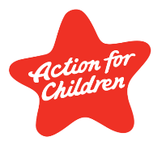
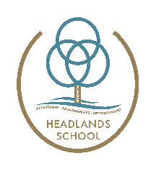

Headlands School
Curriculum Policy 2023/2024

Our vision
Our whole school vision is for our School Communities to create a place where everyone feels like they belong, develop a positive sense of self, and create healthy, meaningful and life-long relationships.
Headlands School is a learning community for young people aged 7 to 19. We offer education to young people who have difficulty accessing learning. Our approach is informed by attachment principles and highly engaging and purposeful educative activities, which are woven throughout the work all staff carry out within both our education and residential settings.
We have developed a comprehensive range of approaches and strategies to support all our young people as they move through their learning communities.
All young people at Headlands School have experienced significant difficulties in both a home and school setting. Many young people learning has been affected by early childhood experiences. We use the principles of Dyadic Developmental Practice (DDP), a relational approach, that is embedded by all staff at Headlands School. We develop our behaviour management skills through regular training and evaluation. We use Therapeutic Crisis Intervention (TCI) as a model to support all pupils improve their coping skills.

Our relational approach
The curriculum incorporates the principles of DDP that is embedded in all our work at Headlands School. The key principles are:
- Providing all pupils with a safe and consistent learning environment
- Ensuring all staff act as positive role models
- Allowing all pupils to have access to a range of learning experiences that meets their needs and builds their academic, social and emotional skills

If the pupils can experience these principles, they can achieve the following outcomes -
- Build a positive sense of self
- Develop positive and trusting relationships
- Develop more effective coping strategies
- Become more curious and compassionate
- Achieve relevant and worthwhile qualifications and engage in a variety of learning experiences

Our curriculum
Our broad, creative and person-centred curriculum is based around the Curriculum for Wales, as well as building on a range of other educational experiences. We work towards an inclusive approach to learning that allows the young people to build skills and progress, often related to their interests.
At Headlands School we aim to build and develop the skills of all young people as they move through the school. At the core of our philosophy is creating a safe learning base from which to develop and build trusting relationships. These are central to allow young people to feel safe, learn and consequently achieve successful outcomes. This underpins all our activities at Headlands School.
We have developed many creative and radical learning experiences that are aimed at engaging all pupils and supporting them to improve a wide range of skills over time. We firmly believe in improving all young people key literacy, numeracy and digital competency skills through a wide range of classroom-based activities as well as many experiences outside the classroom. Our extensive range of purposeful vocational opportunities support the development of these key skills alongside the benefits these activities have on developing key relationships.

Our curriculum uses approaches such as:
- Person-centred planning
- Co-constructed curriculum
- Thematic learning
- Retrospective planning
- Interest-based activities
- Eliciting responses in curriculum design
Relationships and sexuality education (RSE) plays a vital role in enhancing young people well-being and safety. Our Personal Social Education (PSE) team ensure that young people receive the appropriate support and information throughout the whole school.
Human rights and the freedoms and protections to which all young people are entitled play an imperative role in Headlands School. Through Human Rights Education and the United National Convention on the rights of the Child (UNCRC) we support young people to know their rights and respect those of others.
All young people who require additional support have access to various interventions to enable them to improve their specific social and emotional skills. Where required this is supported by psychological consultations.
Our leadership approach
Our leadership approach is an integral part of our school. We actively encourage all staff to take a lead on various projects, share ideas and contribute to school improvement. Our person-centred approach ensures the pupils voice is always listened to and heard, and consequently has an impact on school improvement. We use an inquiry-based model that encourages democratic practice. This support all staff being curious and thoughtful regarding improvement and growth.
Our Self-Evaluation Report (SER) is completed every year and follows the Estyn Inspection Framework. This is done on a learning community and whole school level and is inputted by all members of our school community. The SER evaluates our performance from a variety of sources. This includes using a variety of data such as standardised assessment (see Assessment and Feedback Policy) and performance evaluations including session observations, scrutiny of work, learning walks and listening to learner activities. The information from the SER then feeds into our School Improvement Plan (SIP). This ensures there are key areas of focus in relation to provoking new thinking and supporting meaningful change.

The school is defined by our 4 communities:
Lower School Community
Our Lower School curriculum provide an exciting and differentiated approach to learning which develops a wide range of skills and knowledge. There is an emphasis on thematic and co-constructed learning that provides a broad and balanced range of learning experiences. The curriculum is delivered in a safe, nurturing environment with a key focus on developing key relationships, based on the nurture group principles. The teaching focuses on developing the key skills in the morning, particularly literacy and numeracy. All pupils have access to a wide range of ICT provision to develop their digital competency skills. We use the International Primary Curriculum (IPC) and the Cornerstones Programme to deliver a thematic and pupil centred approach covering the 6 Areas of Learning Experience (AoLE). Pupils also have access to specific PSE, PE, DT, Art and Cycle Studies specialist teachers where they can consolidate these key areas of learning and develop new skills.
Middle School Community
In Middle School we continue to use the nurture principles developed in the Lower School Community. Pupils improve their numeracy, literacy and ICT skills alongside using the International Middle Years Curriculum (IMYC) and a thematic based, person-centred approach to learning to further develop the 6 AoLEs. The young people are based in their classrooms (their safe base) with a key teacher and Teaching Assistants (TA). They also have access to various subject specialist areas including cycle studies, DT, music, D of E, Drama, PSE and PE. These wider opportunities develop wider interests and allow all pupils the opportunity to consolidate and improve their social and emotional skills.
Upper School Community
Young people in Upper School are provided with a broad and balanced range of academic and vocational experiences that promotes independent learning alongside gaining external qualifications. Young people are given the opportunity to complete a range of work-related learning as well as meeting with Careers Wales to discuss future pathways relevant to the individual. The teaching model continues to follow the nurture principles and all pupils have a safe base from which the majority of lessons are delivered. There are a wide range of qualifications that pupils can access and achieve. These include, Entry Levels, Essential Skills Wales, GCSEs, D of E, BTEC, ASDAN and Agored Cymru qualifications.
Post-16 Community
The post-16 programme aims to offer continuity and progression allowing all young people to develop a wide range of skills through an individually tailored pathway. This programme enables all young people to develop key transferable skills in various contexts within a safe and nurturing environment. Through developing these skills and experiences the programme aims to ensure that all young people in post-16 are prepared for the next stage of their educational journey. Careers Wales support all pupils to do this, through regular meetings and information sharing. There is a continued effort to develop appropriate independence skills both in the classroom and during community-based learning. The young people have the opportunity to build upon their qualifications achieved as well as completing courses in a wider range of qualifications including GCSEs and Welsh Baccalaureate.

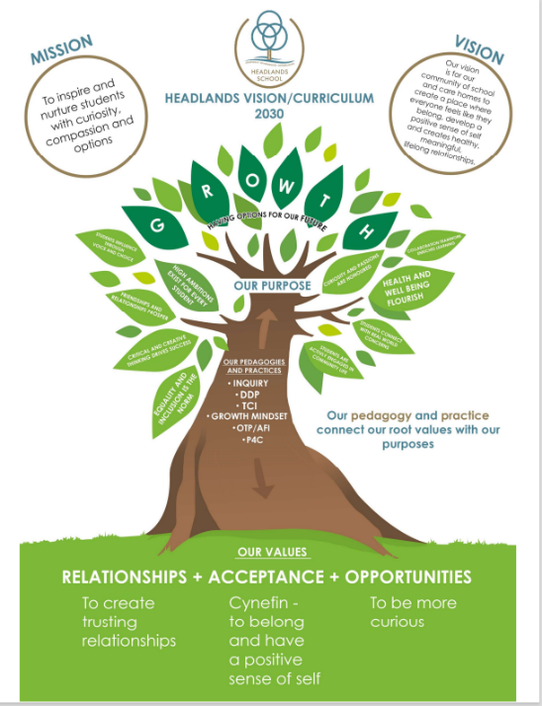

Written by Joe Osbaldeston – Head of Education September 2023
Review September 2024

