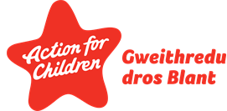
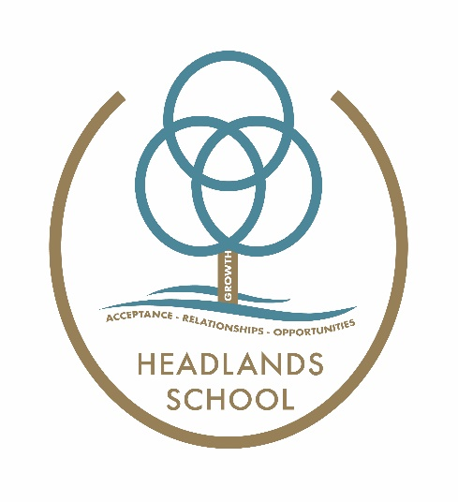

Headlands School
Lesson Observation Policy

This Local Policy conforms to the Independent School Standards Wales Regulations 2003:
Ref: Section 1(2)

Lesson observations are an important aspect in school improvement, the purpose of lesson observations:

- allow the school management to make accurate judgements in relation to the effectiveness of teaching and learning
- share good practice between teaching team
- support the professional development of teachers.
- Observation focus is informed by SIP improvement targets

It is our intention that lesson observations become part of a regular cycle of self-evaluation. They allow us to focus on the school improvement agenda. Teachers will be observed once a term. Two observations will be carried out by mangers or Educational Consultants and one round of peer observations. Estyn annual monitoring visits feed into our observation schedule as part of management observations. During observations a scrutiny of pupils previous work may be observed

PROTOCOLS

- Observation dates given in advance.
- ESTYN observation form used to record observations
- Feedback given to teachers following lesson observations
- Clear objectives will be set regarding the observations.
- Written feedback provided to teacher (copied to manager in the case of peer observation).
- Outcomes of observations generate improvement targets to feed into the SER

This policy will be implemented and reviewed by the Learning Support Team.

Author: LST
Date: September 2023
Review: September 2024

