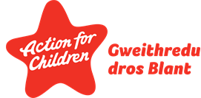
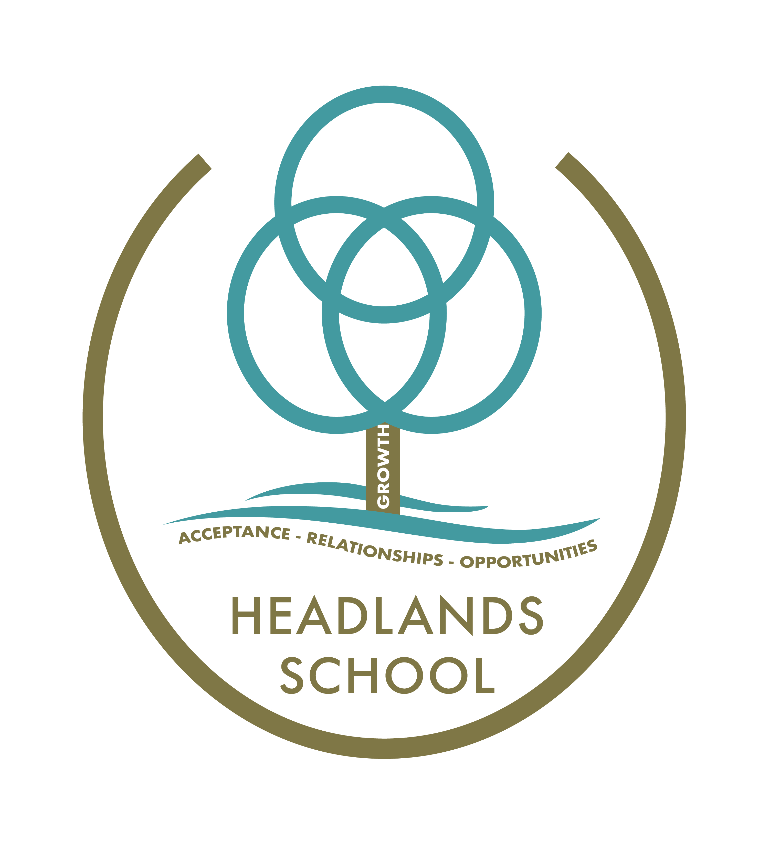

Headlands School
Marking Policy

All feedback to pupils is fundamental to the assessment process and is an important part of teaching and learning. All effective feedback demonstrates a respect for the work produced and can identify the way in which the individual pupil can improve.

Marking and feedback should:

- Be manageable for the teaching team and accessible by the child
- Relate to the learning objective
- Involve the teaching team working with the children
- Give recognition and praise for achievement and effort
- Give clear strategies for improvement
- Be DDP congruent
- Inform future planning
- Be seen as a positive experience by the child

The following methods of marking and assessment are used regularly at Headlands School -

Verbal Feedback – This should focus on successes, areas for development and set future targets. Verbal feedback should be recorded on the pupils’ work and where appropriate, outline specific areas for improvement. When giving feedback to pupils all teachers and teaching assistants should use DDP (Dyadic Developmental Practice) congruent language. This will allow the pupils to develop an understanding of what they have done well and how they could improve. For example, ‘Tell me what you like about this piece of work’ and ‘How would you like to improve this piece of work?’.

Summative Feedback – This is associated with closed tasks where the answer is either right or wrong. It normally involves a tick for a correct answer and a dot for an incorrect answer.

Formative Feedback – This should be an acknowledgement of the work relating to the achievement of the learning objective with a clear target for development. This informs pupils how to extend and improve in the next session. We acknowledge the achievement of the learning objective using symbols. The following symbols are used to identify whether the learning objective has been met and to identify what the pupil needs to do to improve.

- Learning objective achieved
- What the pupil needs to do to improve their work

It is important that teachers and teaching assistants consider the learning objectives when marking a piece of work and relate achievement to this in the main. On a piece of work which is not directly related to handwriting and spelling no more than 3 spelling errors should be highlighted. When highlighting spelling or handwriting errors a line should be placed underneath the error and the correct spelling or letter formation modelled above the error.

All marking should be completed with a green pen.

This policy will be reviewed annually by the Learning Support Team.

This local policy conforms to the Independent School Standards Wales Regulations 2003:
Section 1(3)(g)

Reviewed: SIT
Date: September 2023
Review: September 2024

