
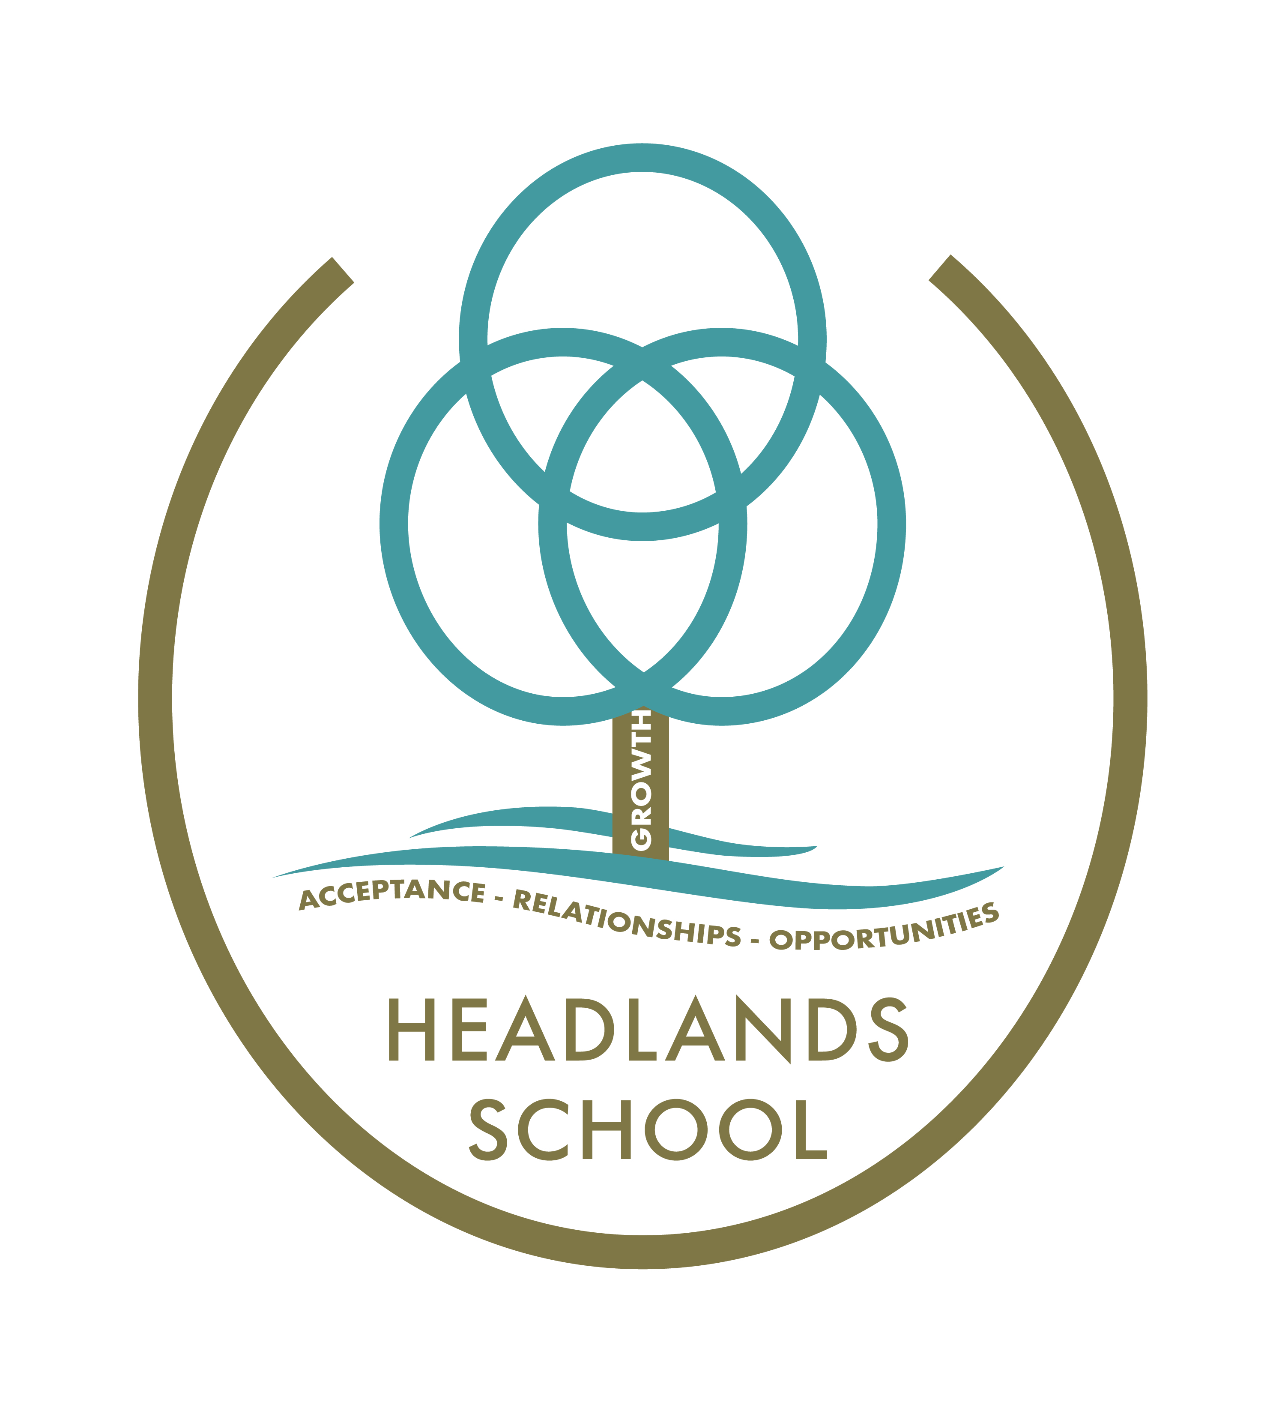

Headlands School
Parent Partnership/Review Policy

One of the key principles of the Children Act is that responsible authorities/others/ Headlands School, should work constructively with the parents/others of all children who attend school; and also with the children themselves where they are of sufficient understanding, provided this approach does not jeopardise their welfare.

A second key principle of the Act is that parents/others and children should participate actively in the decision-making process, where important decisions are being made about the lives of children.

Partnership can only be achieved if parents/others are made aware of the powers and duties that are invested in those other responsible authorities.

These duties require responsible authorities to consult parents and others (and the child where he/she has sufficient understanding) before any decision is made.

Planning and review of children (within the school/residential setting), with the involvement of parents/others, will provide the basis of partnership between the school the parents/others and the child. Regular contact with parents/others ensures a healthy link between staff at Headlands and Parents/Carers.

As a corollary to the partnership arrangement, parents/others and children are entitled to make use of AFC’s Complaints Procedure if they think that a particular aspect of the provision offered by the school breaches one of the welfare principles (as set out in the Children Act), for a particular child.

Author: PST
Date: September 2023
Review date: September 2024

