
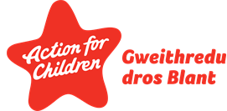
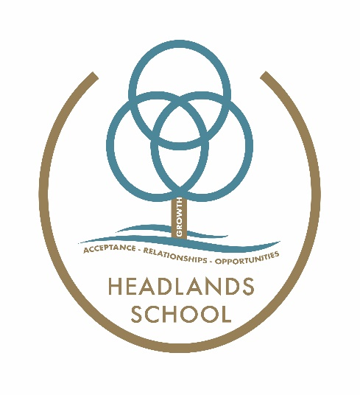

Headlands School
Opportunities for Pupil Participation

At Headlands we work to provide opportunities for pupils to become involved in school life outside of the classroom, in a way that makes the most of their talents and strengths.

Some of the ways we do this are through:

Student Council

Student Council meet fortnightly to consult with senior managers on changes identified in the School Improvement Plan. Previously this has included changes to the IT systems and outdoor equipment. Interested pupils can apply to be a member of student council at the end of each academic year and go through a shortlisting process.

Big Ideas Group

The Big Ideas Group is made up of the pupils who applied for Student Council but were not selected – this is an opportunity for them to work on ideas that are quick to implement such as changes to breaktime activities and suggestions school celebration events. The Big Ideas Group meet monthly with senior managers.

Peer Support

The Peer Supporters are a small group of young people identified as having the ability to empathise with and support other pupils in times of difficulty. They receive training in basic skills such as active listening when joining the team and meet weekly with a senior manager to debrief and plan. This group of pupils roll over academic years with new pupils being recruited to replace leavers, or when the group request more members. Recruitment is led by the existing peer support team.

Focus groups for consultation

Groups of pupils are identified to take part in focus group meetings for consultations – the consultations can be part of wider national consultations such as the Draft Additional Learning Needs Code, or the WAG Anti bullying guidance, as well as internal Headlands changes such as the learning and classroom experience.
These pupils are typically selected from the pupils who are not a part of any other participatory groups, and often held on a 1:1 or 1:2 basis.

Music

The Music department at Headlands School is an inclusive environment where pupils are invited to take part in a wide variety of activities and experiences, both in and out of the classroom. These include learning to play instruments, singing, collaboration with others, going to see professional shows and working towards qualifications. These activities and experiences present pupils with opportunities to develop their skills in a safe and stimulating setting, whilst also being offered the chance to perform in concerts and shows on a regular basis.

Drama

The Drama group has been running for 7 years and is an inclusive group for all. The Drama group has over 30 participants ranging from KS2 – P16, not all are performers some work behind the scenes and help with sound and media. In Drama I try to promote independence and personal identity. It is a safe space where pupils can be whoever they want to be. They get to practice a variety of skills in a fun way ranging from reading, writing, speaking, empathy, cooperation, confidence and creative skills. They learn about real life events and relationships through discussion and role-play.

Sport

Learners at Headlands School have the opportunity to access Physical Education. During PE lessons learners take part in a range of activities, including traditional sports like; Football, TAG Rugby, Badminton and Basketball and they also have the opportunity to access different sports and physical activities including: Orienteering, Problem Solving and Strength and Conditioning. Learners can also represent the school in festivals and tournaments across South Wales in Football, Athletics, Tag Rugby and Swimming.

Outdoor activities

Outdoor Education at Headlands School covers a range of different topics including: Forest School, Outdoor and Adventurous Activities and The Duke of Edinburgh’s Award. Learners can access lessons including: Use of Tools, Safe Fire Lighting and Shelter Building, as well as Walking and Cycling Trips. We are in a fortunate position that we are a Duke of Edinburgh’s Award Licensed Centre and can use the fantastic opportunities that the school has to offer to support the accreditation of The Duke of Edinburgh’s Award. Outdoor Education is underpinned by one of the most important factors in life. Play.

Spokes

Spokes is Headlands School Bike Repair Shop. Spokes provides opportunities for pupils to complete Agored Level 1 in Bike Mechanics alongside developing key skills in a variety of work-based activities.
Spokes maintains all of Headlands School bikes on a regular basis as well as providing a high quality repair service for the general public. Spokes also develops pupil’s bike riding skills through a thorough Cycling Proficiency Programme. This ranges from on-site and local rides, to cycling trips following the Tour de France.

Author: SIT
Date: September 2023
Review date: September 2024

