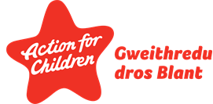
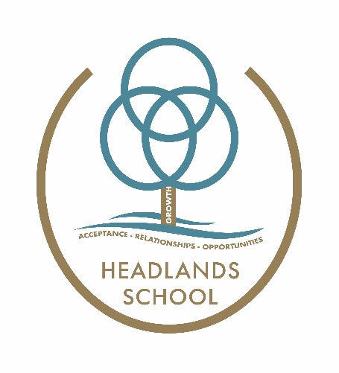

Headlands School
Person Centred Planning Policy

Introduction
At Headlands School we believe in a person-centred approach because it ensures that children are at the centre of decisions that relate to their life.
Person centred practice support relationships to become more productive and positive and information and communication flow more easily.

Our approach and tools
A person-centred process involves listening, thinking together, coaching, sharing ideas, and seeking feedback. To do this we use a range of tools to support our children to contribute to decision making.

Person centred tool | Why do we use it? | Who is it for?
One Page Profiles | A one-page profile is the foundation of personalised support – it describes a pupil’s character, talents, what is important to them and the best way to support them and can be easily shared and understood. | All pupils and staff. This document is particularly useful to support pupils through a transition.
Good day – Bad day | This tool is used to gather information on what makes and individual’s day good or bad, and what we can do to make sure they have more good days than bad days. | For those children who need a bit more support developing a sense of self.
Communication chart | This tool allows us to ensure that everyone who works with a learner gets to know them and responds consistently to their communication.  We can identify what the individual is communicating through their behaviour, and how they want us to respond. | The children with additional communication needs.
Relationship circle | This is a visual representation of the important people in a child’s life which can be used to help strengthen existing relationships and develop new ones. If a child needs support the relationship circle can help to identify who might be able to offer it. | Our children who are Looked After or in 52-week residential care – where their systems can involve many people and can be complicated, OR, for our children who have limited opportunity to develop relationships/friendships outside of school.
Aspiration chart | Helps us to understand, based on an individual’s gifts and talents, what is important to them, what they want to be and what they want to do. | Children and young people embarking on transition through the school.

These tools support our work with pupils and parents and celebrate what makes our pupils unique and valued and contribute to effective person-centred reviews.
Targets set in reviews are close to the needs of the pupil and therefore more easily attainable, and all those in attendance are accountable and committed to success. Parents, pupils and professionals are equal partners and the meeting is carried out with the pupil at the centre.

HLTAs, Heads of Key stages and House managers will identify the children and young people who require the relevant tools to support them.

Tools can be used practically in the classroom and residential houses and will be stored in Digital Case Files under ‘Plans’.

Author: PST
Date: September 2023
Review date: September 2024

