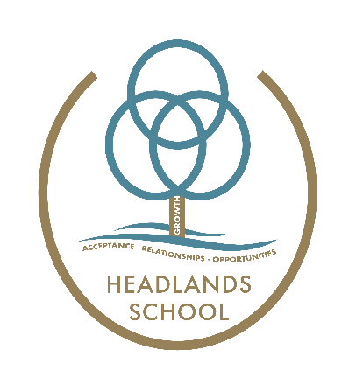
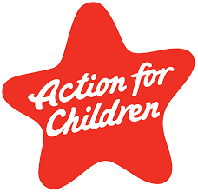

Headlands School
Middle School- Teaching and Learning Policy 2023/24

This local policy conforms to the Independent School Standards Wales Regulations 2003:
Section 1(2)(a)(ii) - 1(2)(b) - 1(2)(c)

This policy describes the approach to teaching and learning within the middle school department at Headlands School. It is essential reading for members of staff new to the school who should incorporate its principles into their practice. It should also be reviewed regularly by current members of staff. It should be fully understood in the context of the whole range of Headlands Schools’ other policy documents.

Pupils are grouped to their learning needs. The majority of groups are full nurture groups and where appropriate certain groups aim to promote transition into key stage 4.

The Middle School Curriculum

In middle school we provide an engaging, differentiated approach to learning which develops skills, knowledge and understanding through relevant and practical experiences. We use the four main purposes set out in the Successful Futures report to ensure we are meeting the needs of the pupils. The four purposes of the curriculum are –

- ambitious, capable learners, ready to learn throughout their lives
- enterprising, creative contributors, ready to play a full part in life and work
- ethical, informed citizens of Wales and the world , ready to be citizens of Wales and the world
- healthy, confident individuals, ready to lead fulfilling lives as valued members of society

The four purposes are supported by the delivery of skills within the six areas of Learning and Experience, namely Expressive Arts, Health and Wellbeing, Humanities, Languages, Literacy and Communication, Mathematics and Numeracy and Science and Technology. Each area of learning and experience contribute in different ways to the pupil’s development of skills. This is set out in the teaching model. Teachers work collaboratively with one another, pupils and the local community to co-construct a curriculum that is interesting, relevant and engaging for each learner.

Middle School Curricular Aims

The teachers in middle school are currently designing a new integrated curriculum. We have pilot groups who are quite far advanced in what they are doing. Some groups are still using IMYC and using the theme from there.
Below is how the teachers using the pilot are trying to co-construct the curriculum with the pupils;

- Eliciting responses from pupils – this includes school trips, interviews with local business and other activities to discover what interests our pupils have
- Creating a theme from responses – teaching teams have approx. two weeks at the start of term to come up with a theme for the term ahead
- Creating an essential question and big idea

The curriculum is delivered in a safe, nurturing environment developing emotional wellbeing and encouraging positive social interactions. Our behaviour management model (TCI) works at developing pupils’ coping strategies whilst our DDP approaches utilise strategies to support pupils develop their relationships.

Approaches to Teaching and Learning

In Middle School we believe that teaching and learning can happen anywhere. Our timetable should reflect that, in that not all pupils are based in classrooms for all their sessions. We use the local community for many of our timetabled lessons.
The school day can be very individualised for some pupils, but in general teachers try to get literacy, numeracy and ICT completed in the morning sessions and then use the afternoon sessions for more thematic learning.

Transition and Co-construction

Teachers set up activities to elicit what is important to the students and what they feel they need to know and learn about.

Many of our pupils have individual timetables which involves them being offsite for their learning. We use the local swimming pool, white water rafting centre and boulders to help our pupils and staff build relationships. These activities also help pupils raise their self esteem and work better as part of a group. We also take bikes out along the barrage and along the Taff Trail. Some key skills are practiced in Penarth town centre such as using the post office or ordering a cup of tea in a café.
Local beaches, forests, castles and other sites of interest are used frequently to remind the pupils of the land they live in and to teach about its history and culture.

Compulsory, ‘non-negotioables’
In middle school we have a focus on developing skills, with a focus on literacy, numeracy and digital competence.

Literacy skills are developed through sessions focussing on the key skills of spelling, handwriting, reading and writing, The school uses the White Rose Maths scheme as its main vehicle for numeracy development; and ICT sessions are taught in line with the digital competence framework.

These core areas of learning are woven through the wider curriculum in order for learners to embed and further develop their skills in a variety of contexts.

ICT is used in innovative ways to extend and enrich pupils’ learning experience, including the use of iPads, a large variety of apps, green screen and editing software.

All staff are encouraged to use OTP (Outstanding Teaching Programme) strategies in their work with the pupils, providing more opportunities for a collaborative approach.

Learning Environment

The middle school is modelled on the practice of Nurture Groups and strictly follows the six Key Nurture Principles:
- Children’s learning is understood developmentally
- The classroom offers a safe base
- Nurture is important for the development of self-esteem
- Language is a vital mean of communication
- All behaviour is communication
- Transitions are significant in the lives of children

Classroom displays are used to enhance pupils learning and display pupils’ achievements, these are updated termly.

The learning environment is not limited to the classroom however. The school grounds are used throughout the day to enhance the learning. Some pupils in Middle School need to use the swings in order to self regulate. Pupils also like to use the onsite farm.
The football pitch is used by many to practice their relationships with others when put into a larger group.
The zero waste shop is used by pupils to give them some responsibility and independence. The Spokes bike repair shop gets used daily by pupils in Middle School. Some go there to learn bike maintenance skills. Others like to go down there and ride the bikes to self regulate. Many pupils have cycling included in their curriculum and go offsite in the local area with staff for bike rides.
The voice radio is used to develop pupils speaking and listening skills. They like to go there and record podcasts.
The music studio is another area that the pupils use to develop their musical skills.

Additional learning needs

Where pupils are identified to have specific additional learning needs, the staff team around them will utilise the curriculum approach to allow them to feel safe and develop their social and emotional skills. These interventions aim to support pupils working in small groups to make good progress. Educational experiences and off site visits and activities are an essential part of the curriculum in key stage three. All pupils have the opportunity to take part in school trips and activities. The aim of these trips and activities is to let pupils experience an understanding of the world around them, consolidate and enhance the learning that takes place in the classroom and to allow the pupils the opportunity to share experiences with their peers and adults.

Progression

Staff in middle school use Progression steps and the Boxall Profile Online as the main tools for tracking academic and social and emotional progress. Teachers use assessments to help inform planning and improve learning as well as to indicate the stage a pupil is with their learning. Pupils are encouraged to use self -assessment and peer assessment to focus areas for development and identify strengths.

Middle school data is used to formulate the SER and SIP. We evaluate key data on pupil progress on a termly basis to identify our strengths and areas for improvement.

In middle school we carefully and thoughtfully prepare pupils moving into upper school. Careers interviews and reviews are included in the transition plan to allow a clear pathway for the pupils to work towards.

We are going to use journals to tell the story of growth that our pupils make. We will use pictures and videos to show the progress. We want tell the story of how the pupils were when they came to us and how they progress over time. The platform we will use will be Seesaw.

.

